Lewis Capstone Project Documentation

Quality test automation
Sachin Kirsten Brown
2026
Verify Prerequisites

# Check .NET 8
dotnet --version
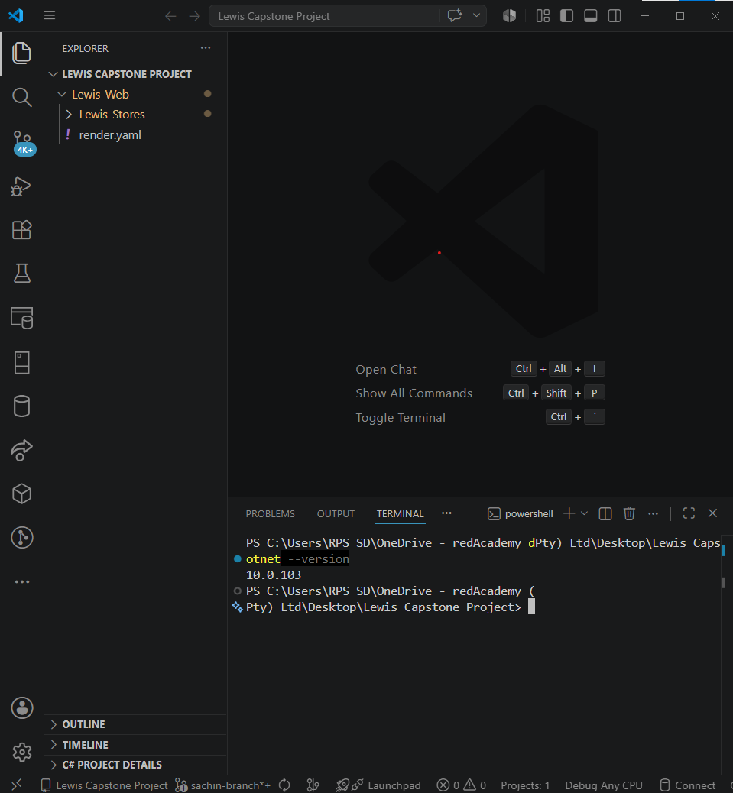

# Check Node
node --version
npm –version
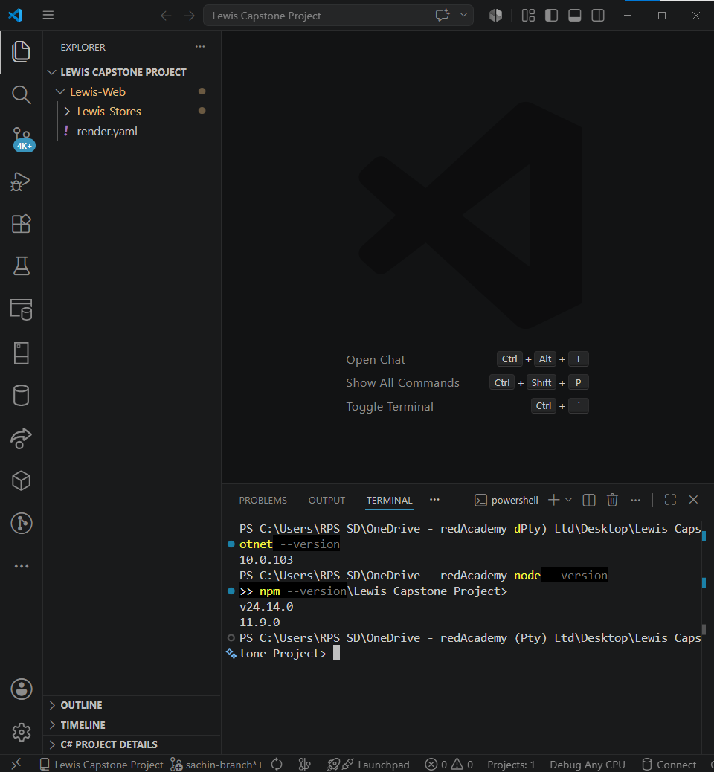

# Check SQL Server
sqlcmd -C -S localhost -Q "SELECT @@VERSION"

Run the Automated Setup
.\setup-scripts\01-setup-complete-system.bat
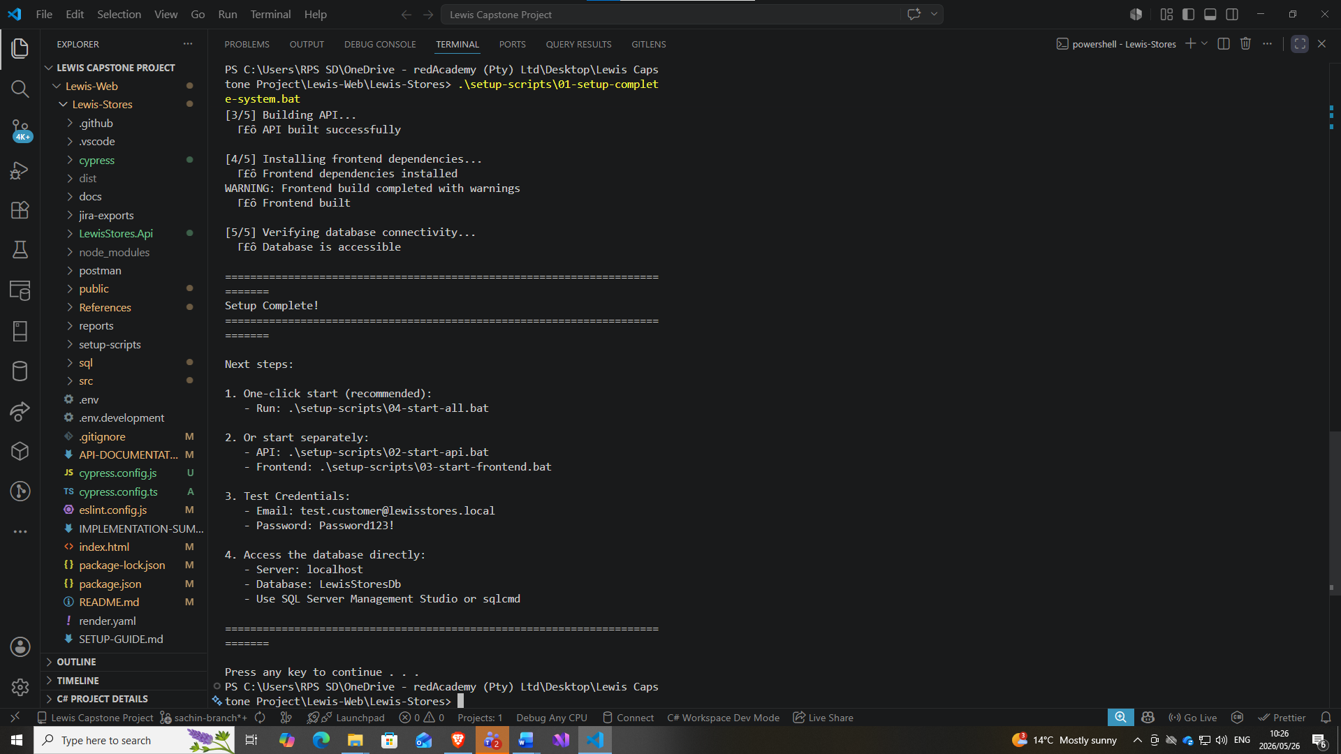
Verify the seed data:
sqlcmd -C -S localhost -d LewisStoresDb -Q "SELECT COUNT(*) AS Products FROM Products"
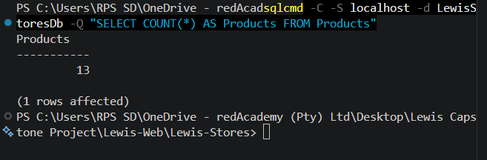

sqlcmd -C -S localhost -d LewisStoresDb -Q "SELECT COUNT(*) AS Users FROM Users"
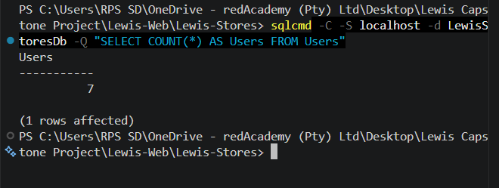

sqlcmd -C -S localhost -d LewisStoresDb -Q "SELECT COUNT(*) AS Orders FROM Orders"
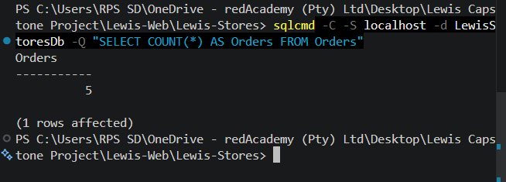
TO-DO

Cypress: Order Management
- Products load and display correctly on storefront
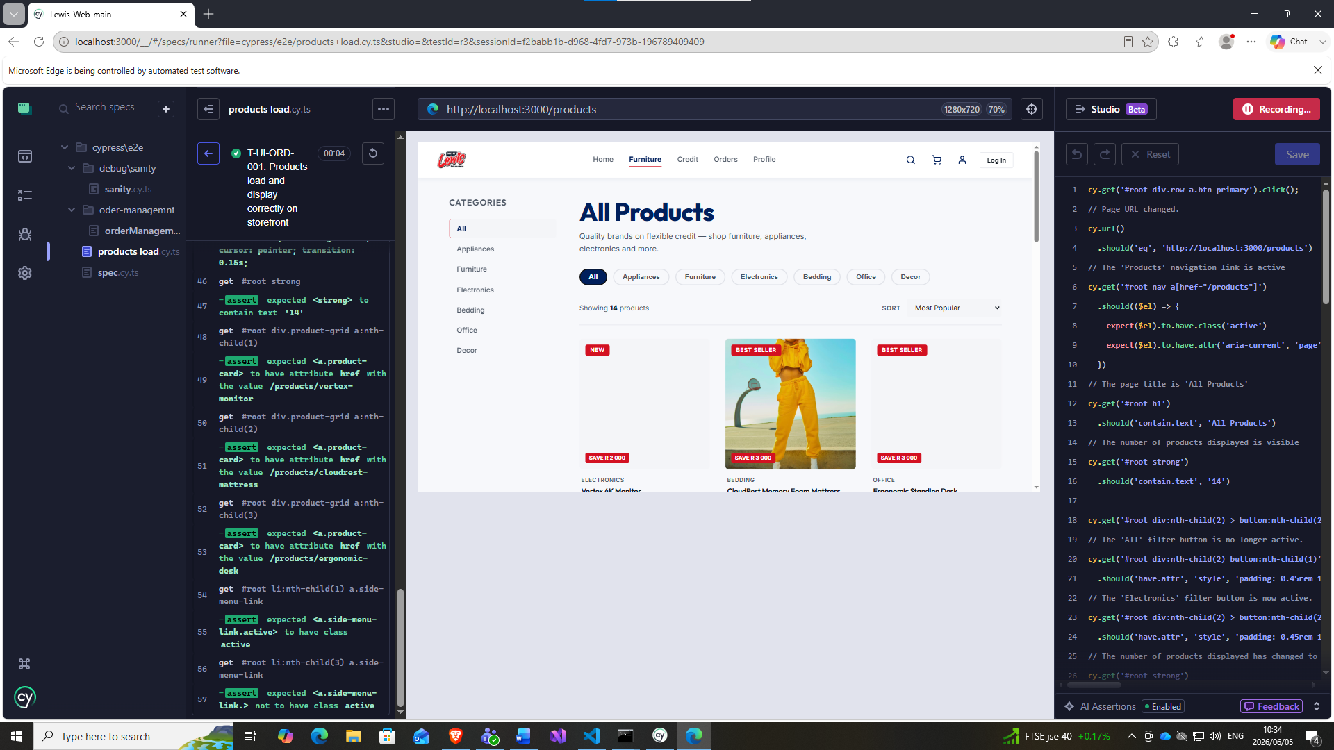
Products load correctly but do not show all the photos of certain items (BUG)
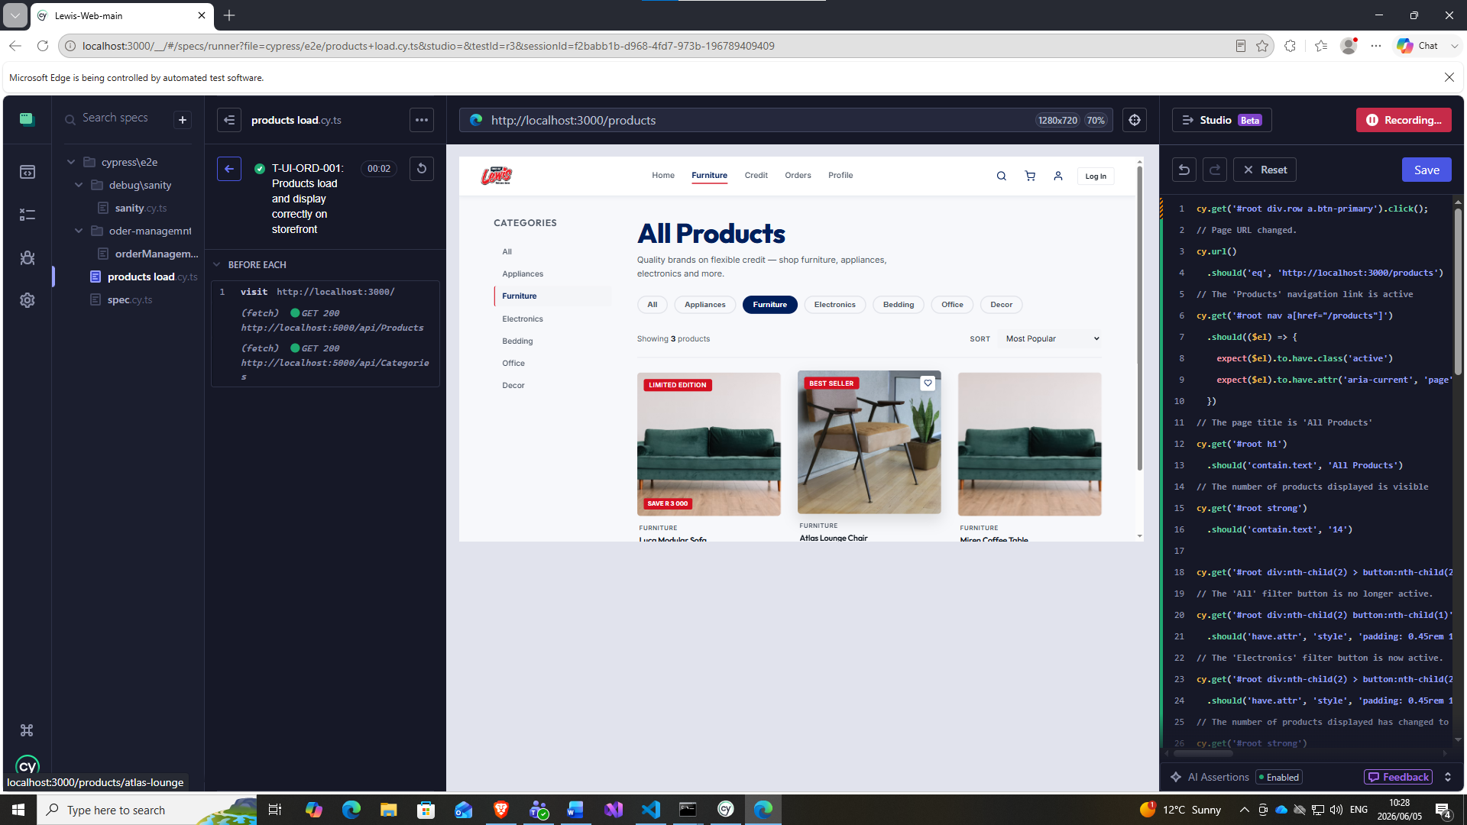

- Add a product to cart with valid quantity
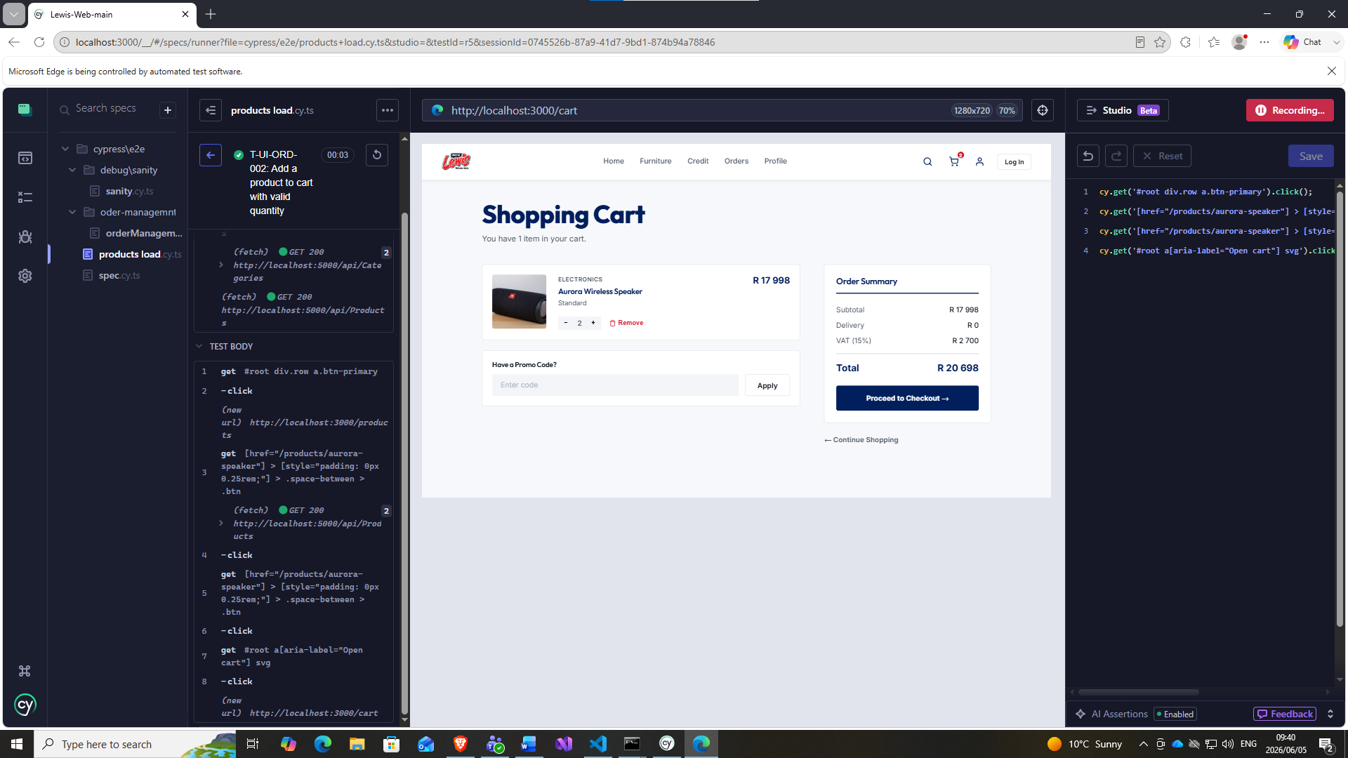

- T-UI-ORD-003: Remove product from cart - Order total updates correctly
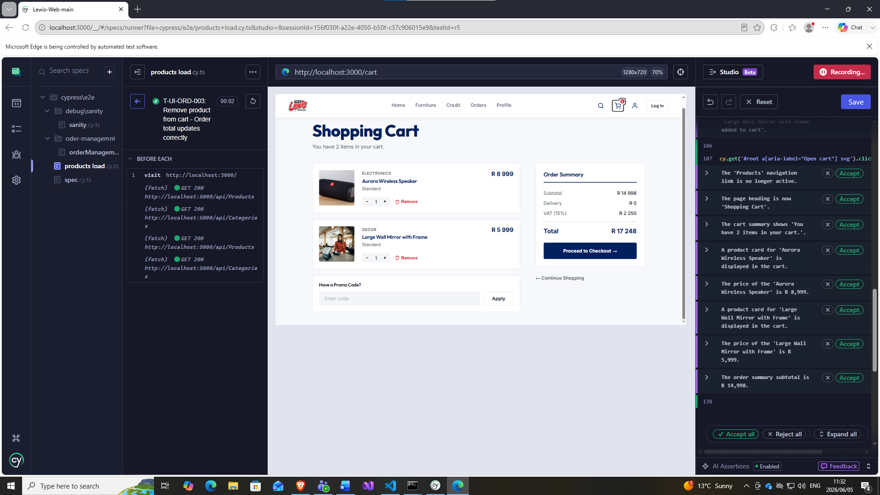
Added 2 products
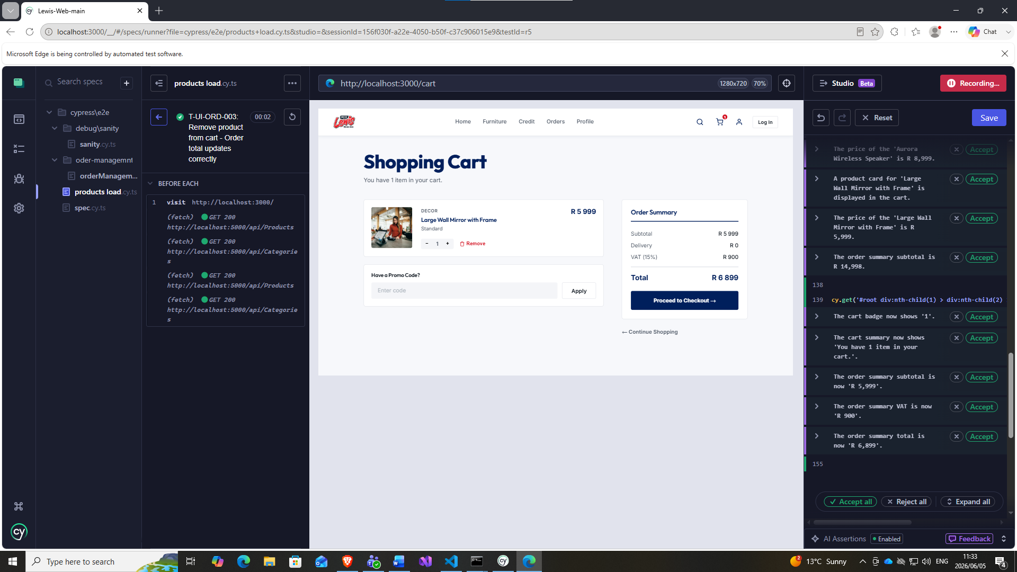
Removed 1 item from cart and correct totals calculated.

- T-UI-ORD-004: Order Total Calculated Correctly (items x price + tax)
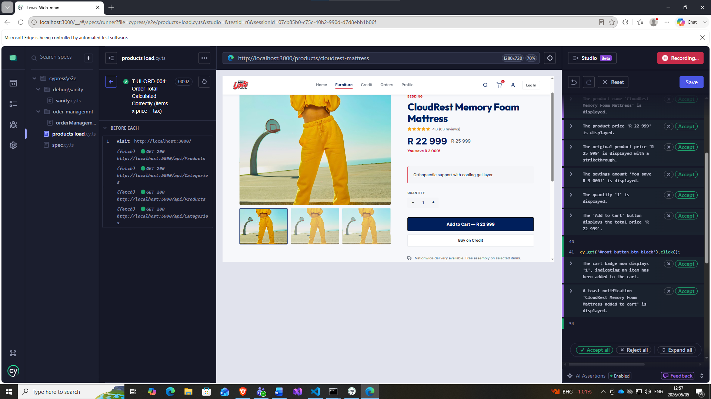
Defect – incorrect image shown for Memory Foam Mattress

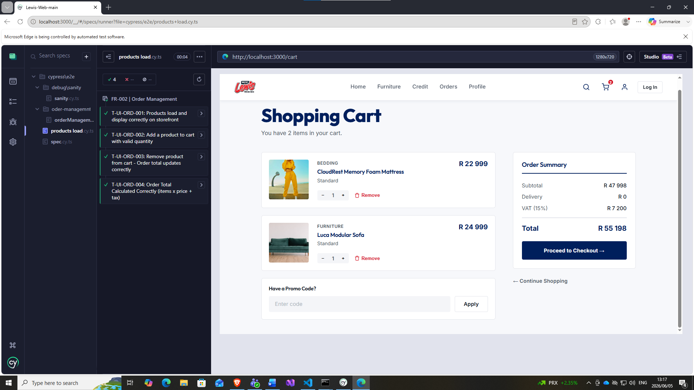

- T-UI-ORD-005: Invalid coupon code shows error - Total unchanged
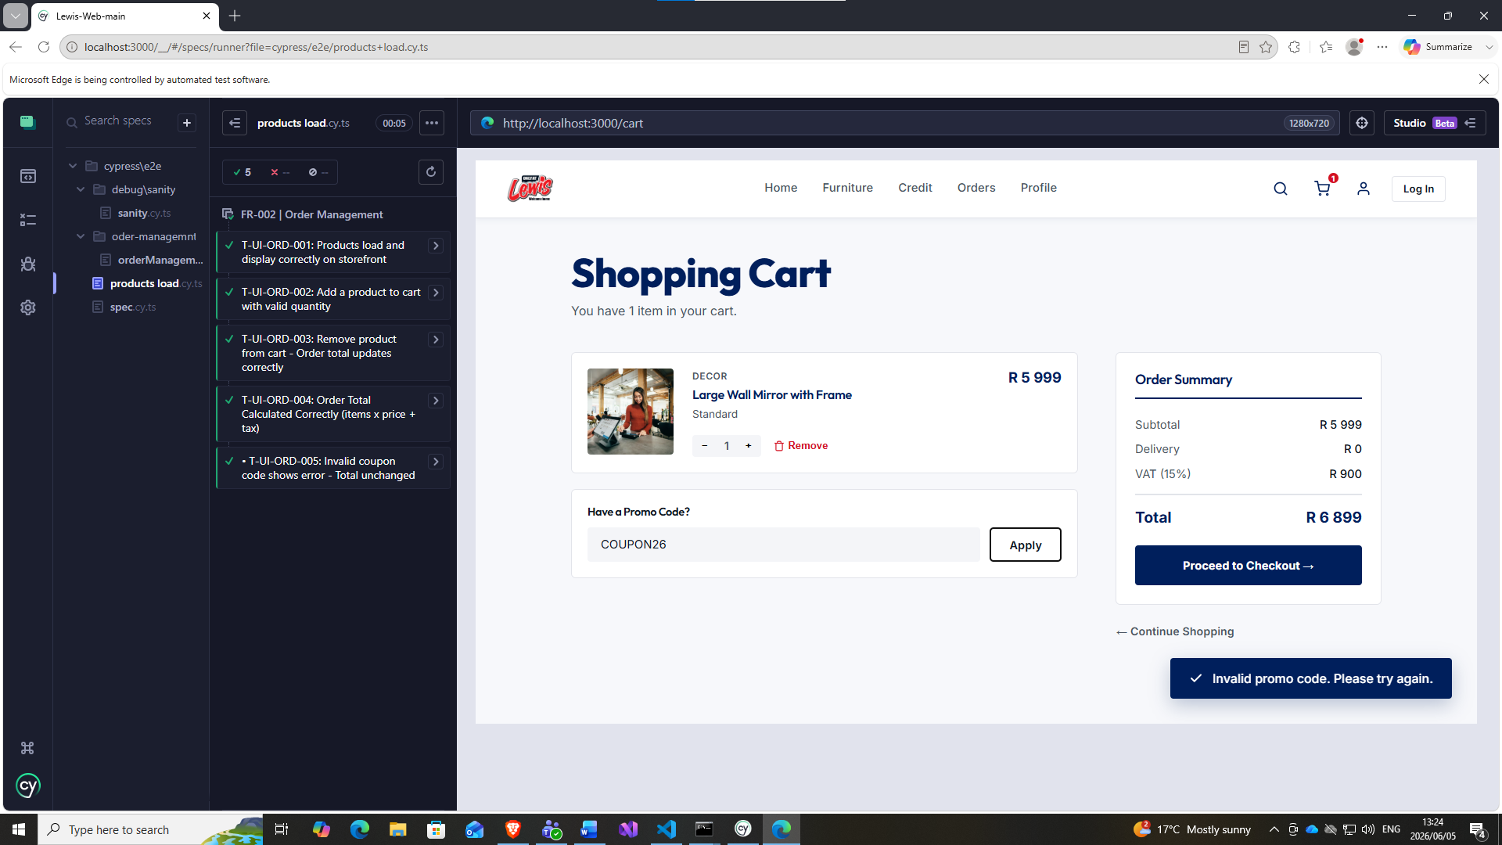
DEFECT – wrong image for large mirror

- T-UI-ORD-006: Modify order quantity before payment - total updates
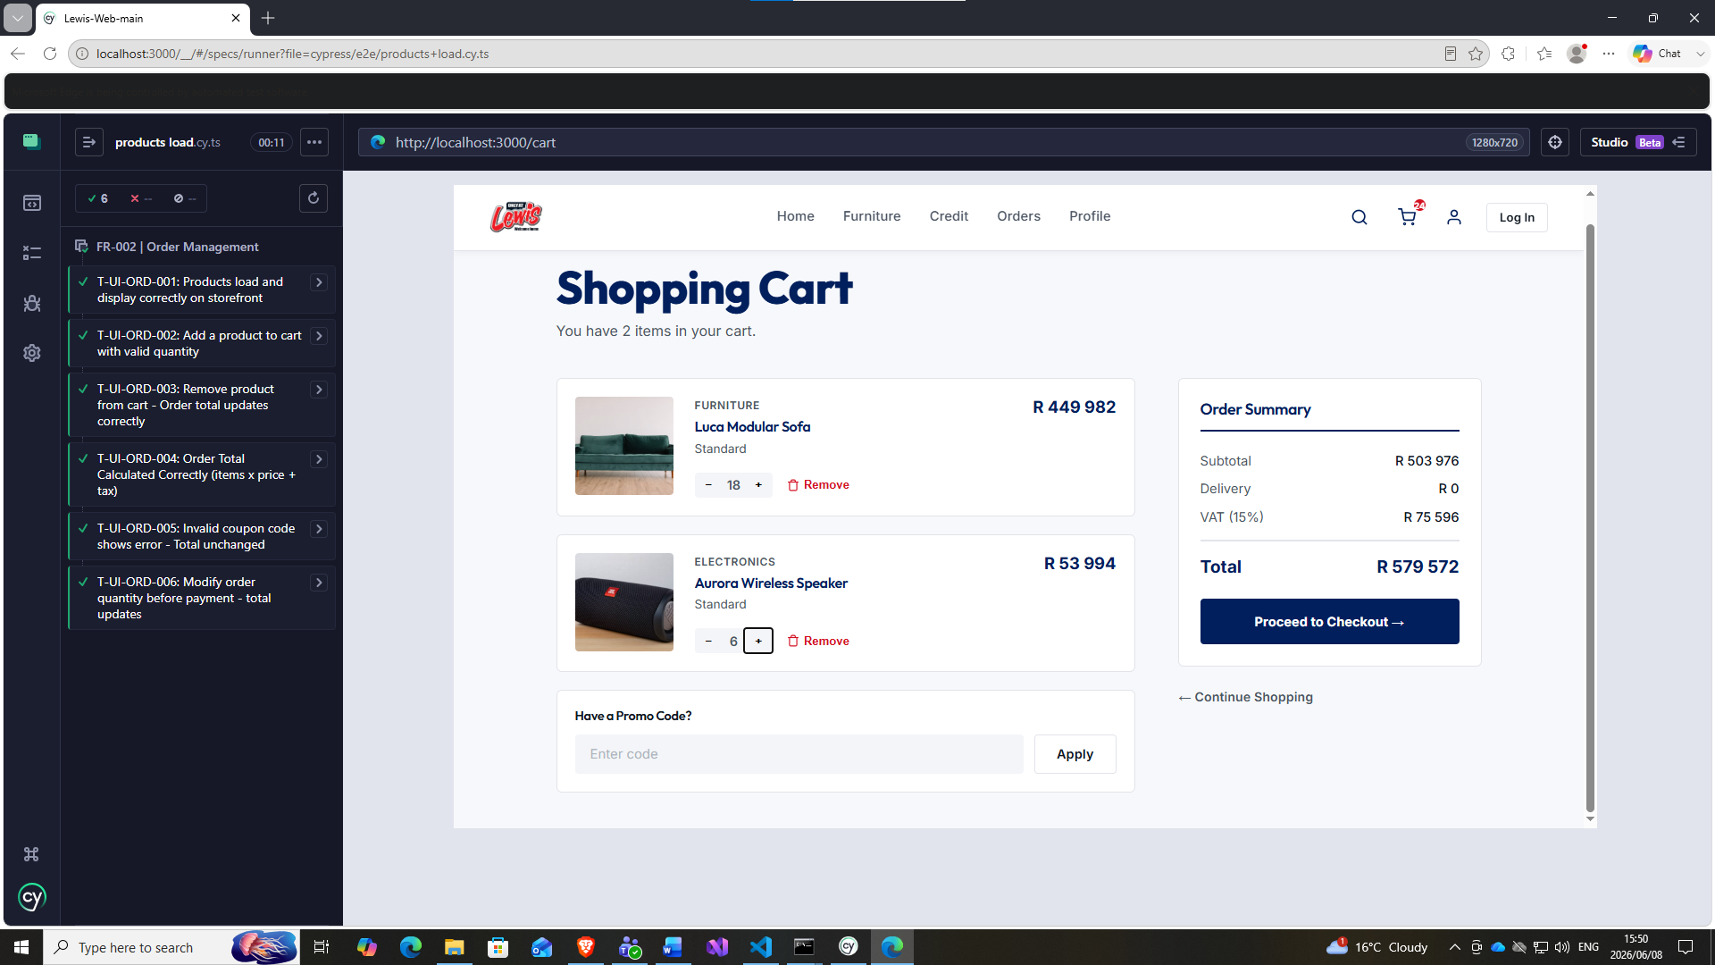

- T-UI-ORD-007: Cannot modify payment after order is confirmed
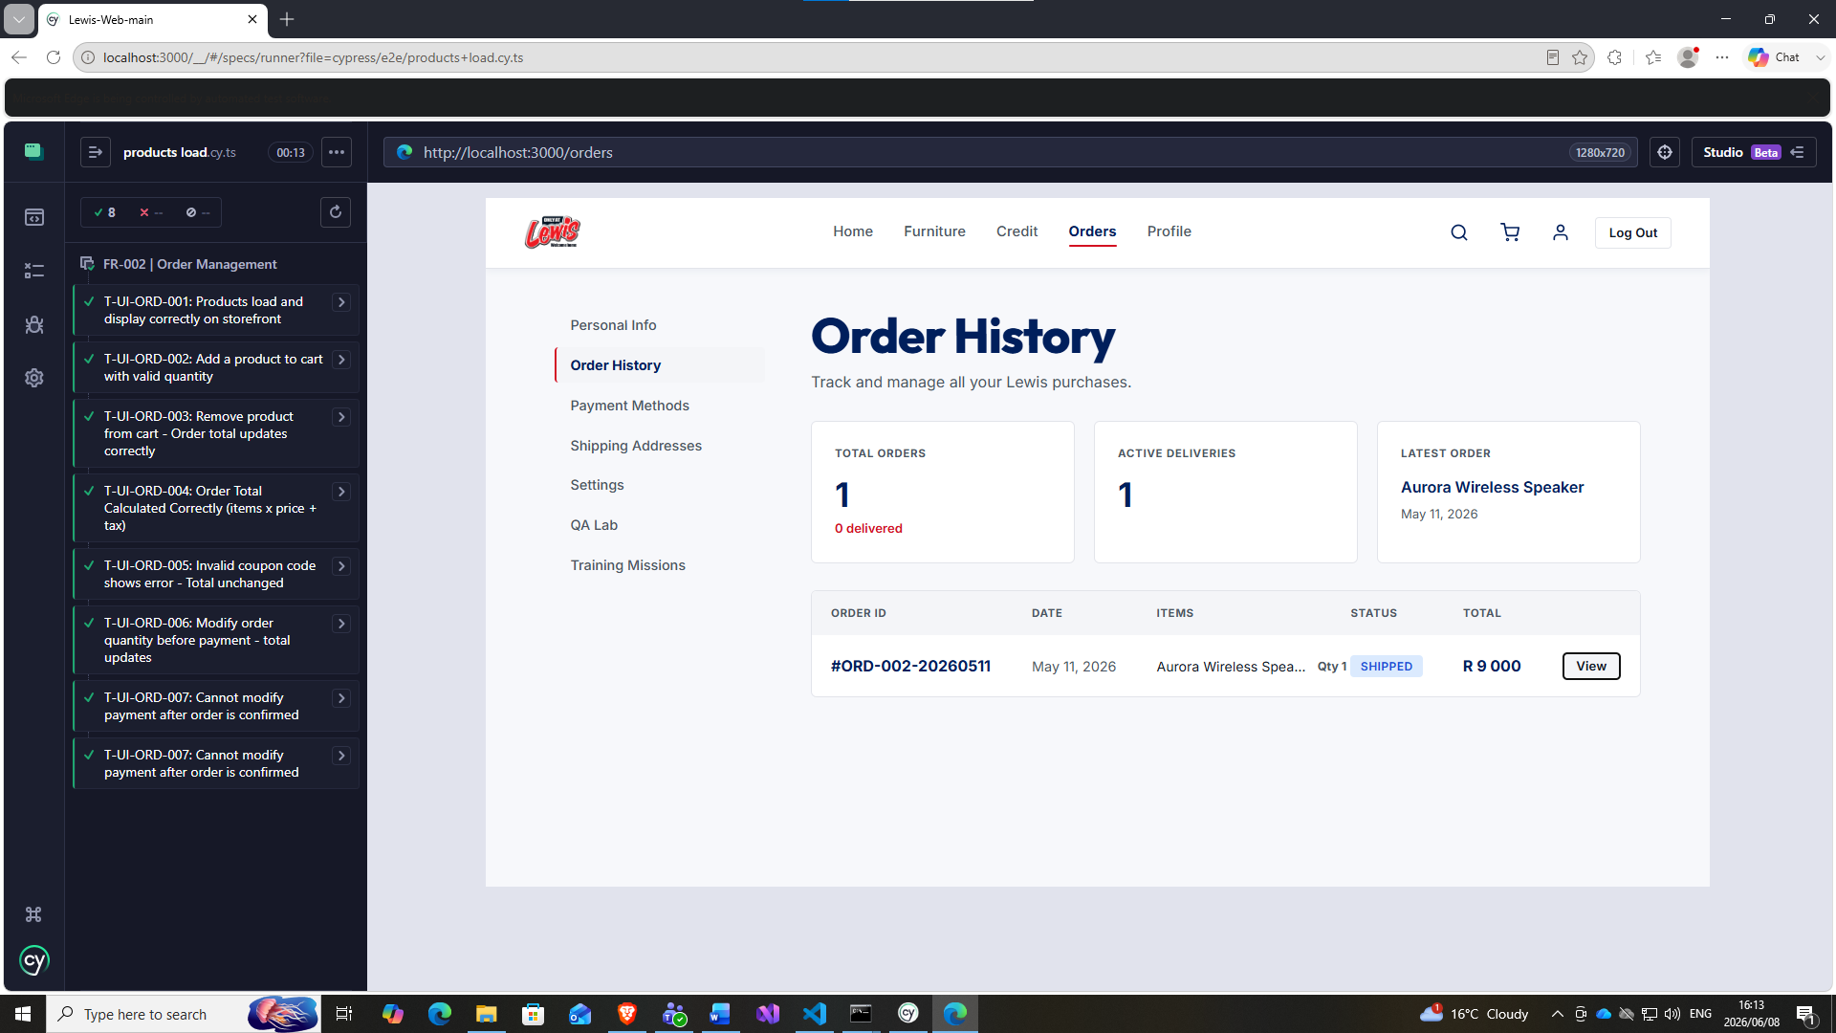
DEFECT “View” button does not work

- T-UI-ORD-008: Cancel order before payment - inventory restored
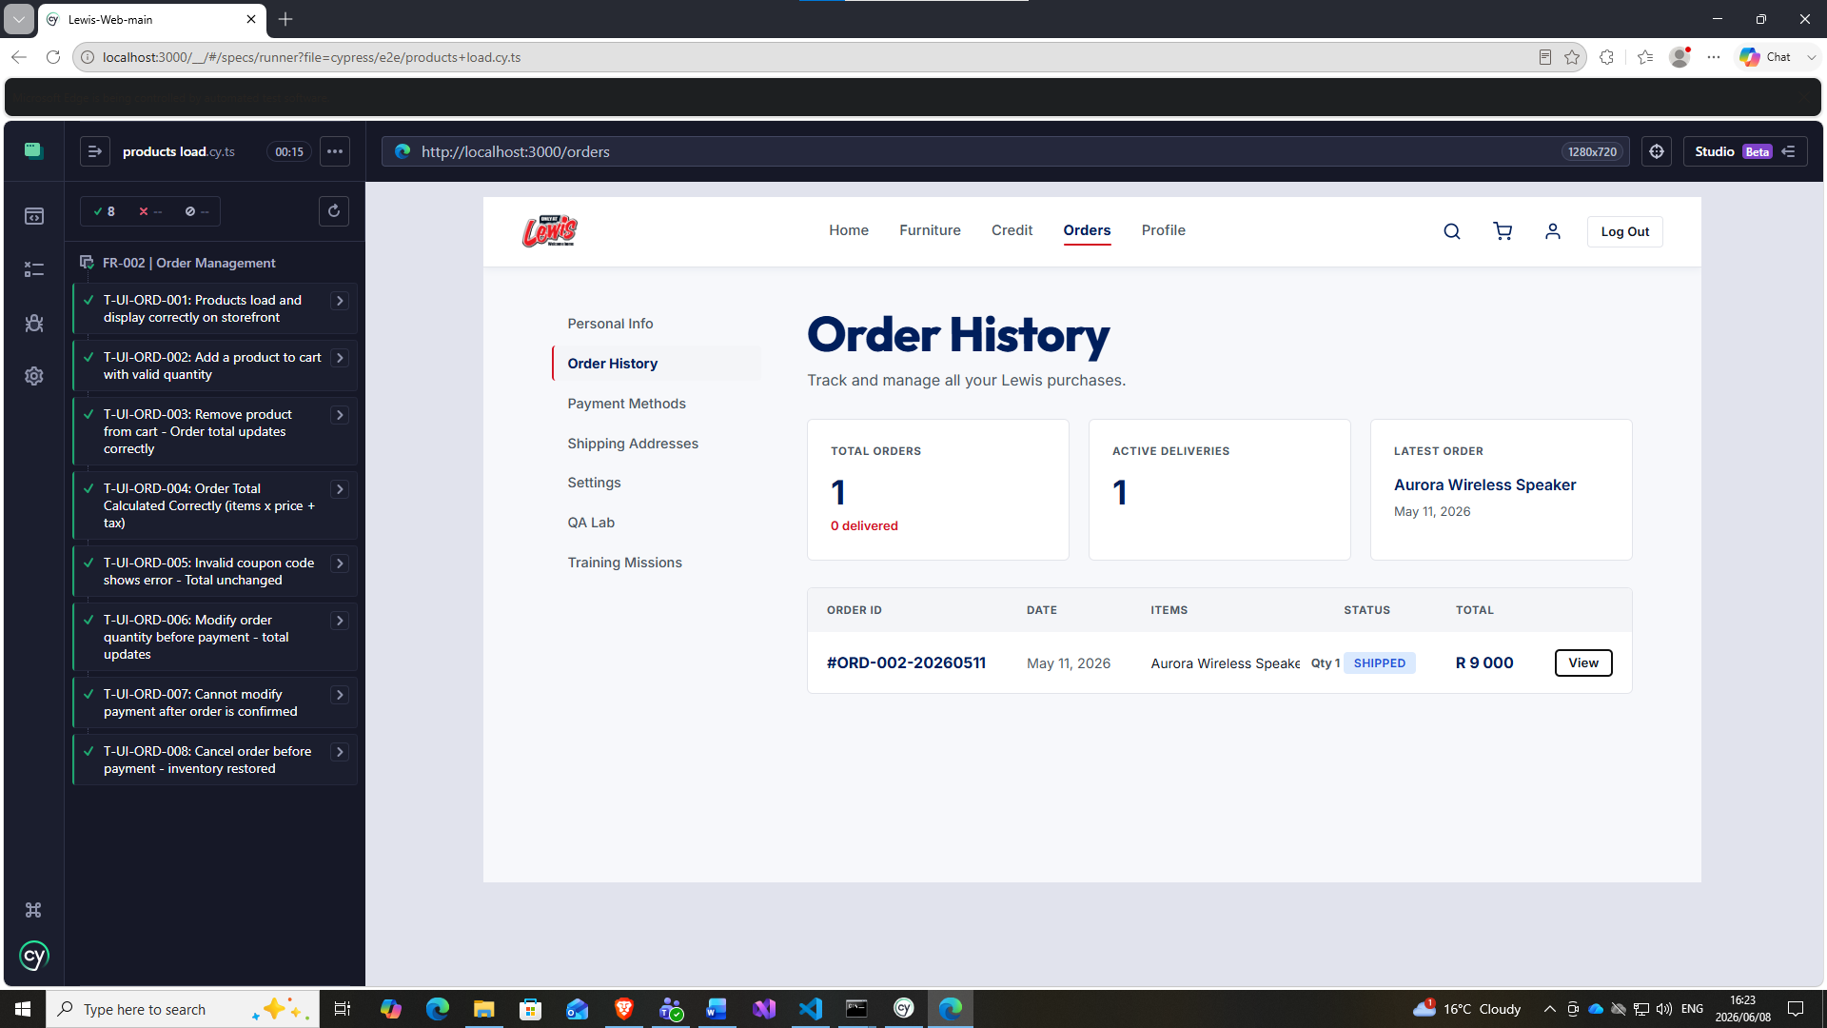
Cannot cancel order before payment, “View” button does not work.

- T-UI-ORD-009: Idempotency - Double clicking checkout does not duplicate order
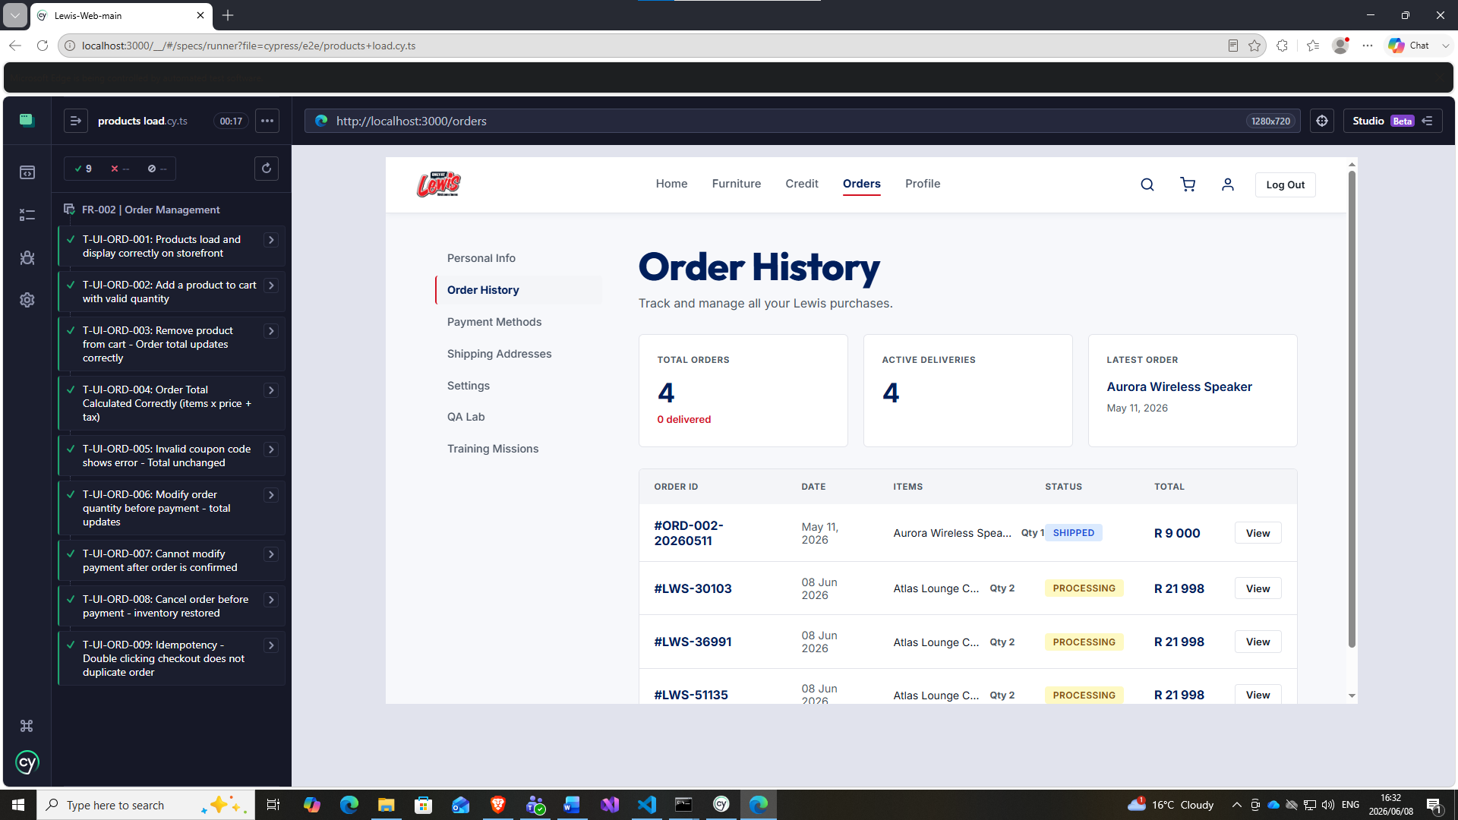
No Idempotency, duplicates created

- T-UI-ORD-010: Quantity Validation - Zero & Negative quantities rejected
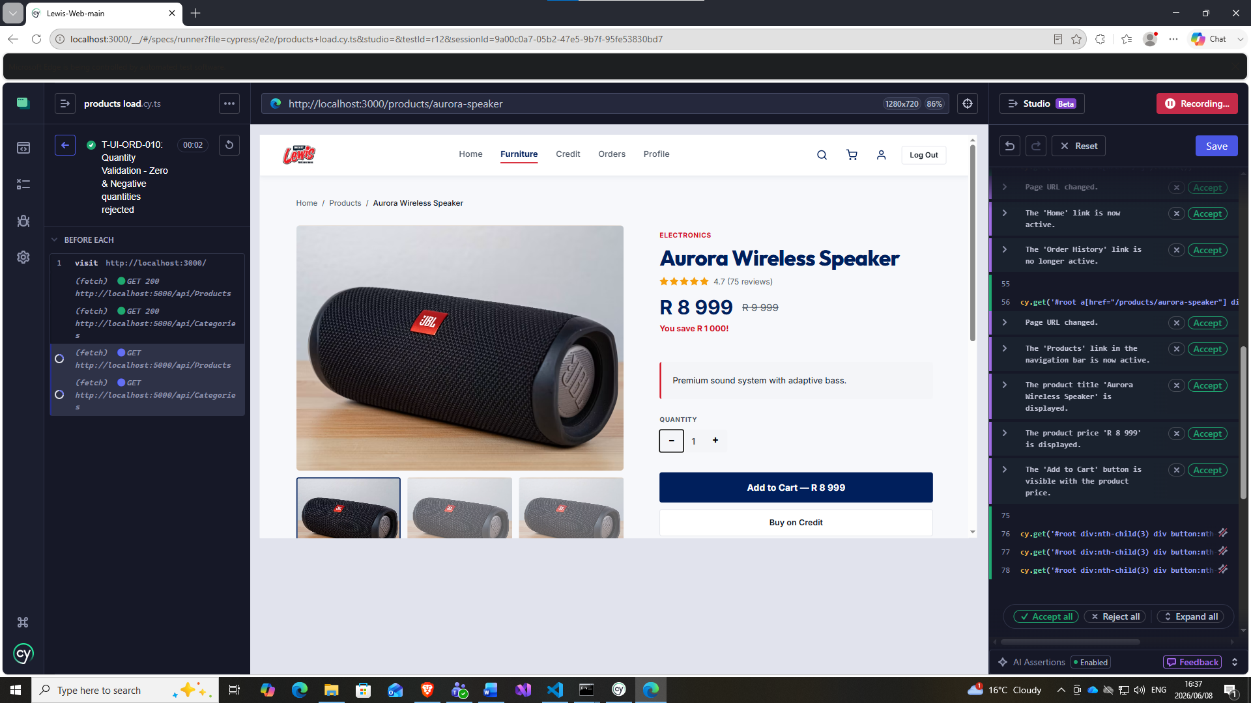
System does not allow zero or negative quantities.

4 SQL queries to verify shipment data integrity.
- Every paid order has a corresponding shipment record

-- ============================================================ -- T-DB-SHP-001 -- Every paid order has a corresponding shipment record -- Expectation: Zero rows returned (no orphaned orders) -- ============================================================ SELECT o.[Id] AS OrderId, o.[Status] AS OrderStatus, o.[UserId], o.[Total], d.[Id] AS DeliveryId FROM [Orders] o LEFT JOIN [Deliveries] d ON d.[OrderId] = o.[Id] WHERE o.[Status] NOT IN ('Cancelled', 'Pending') -- Paid/active orders only AND d.[Id] IS NULL; -- No delivery record exists GO -- PASS if 0 rows returned -- FAIL if any rows returned (orphaned order found)
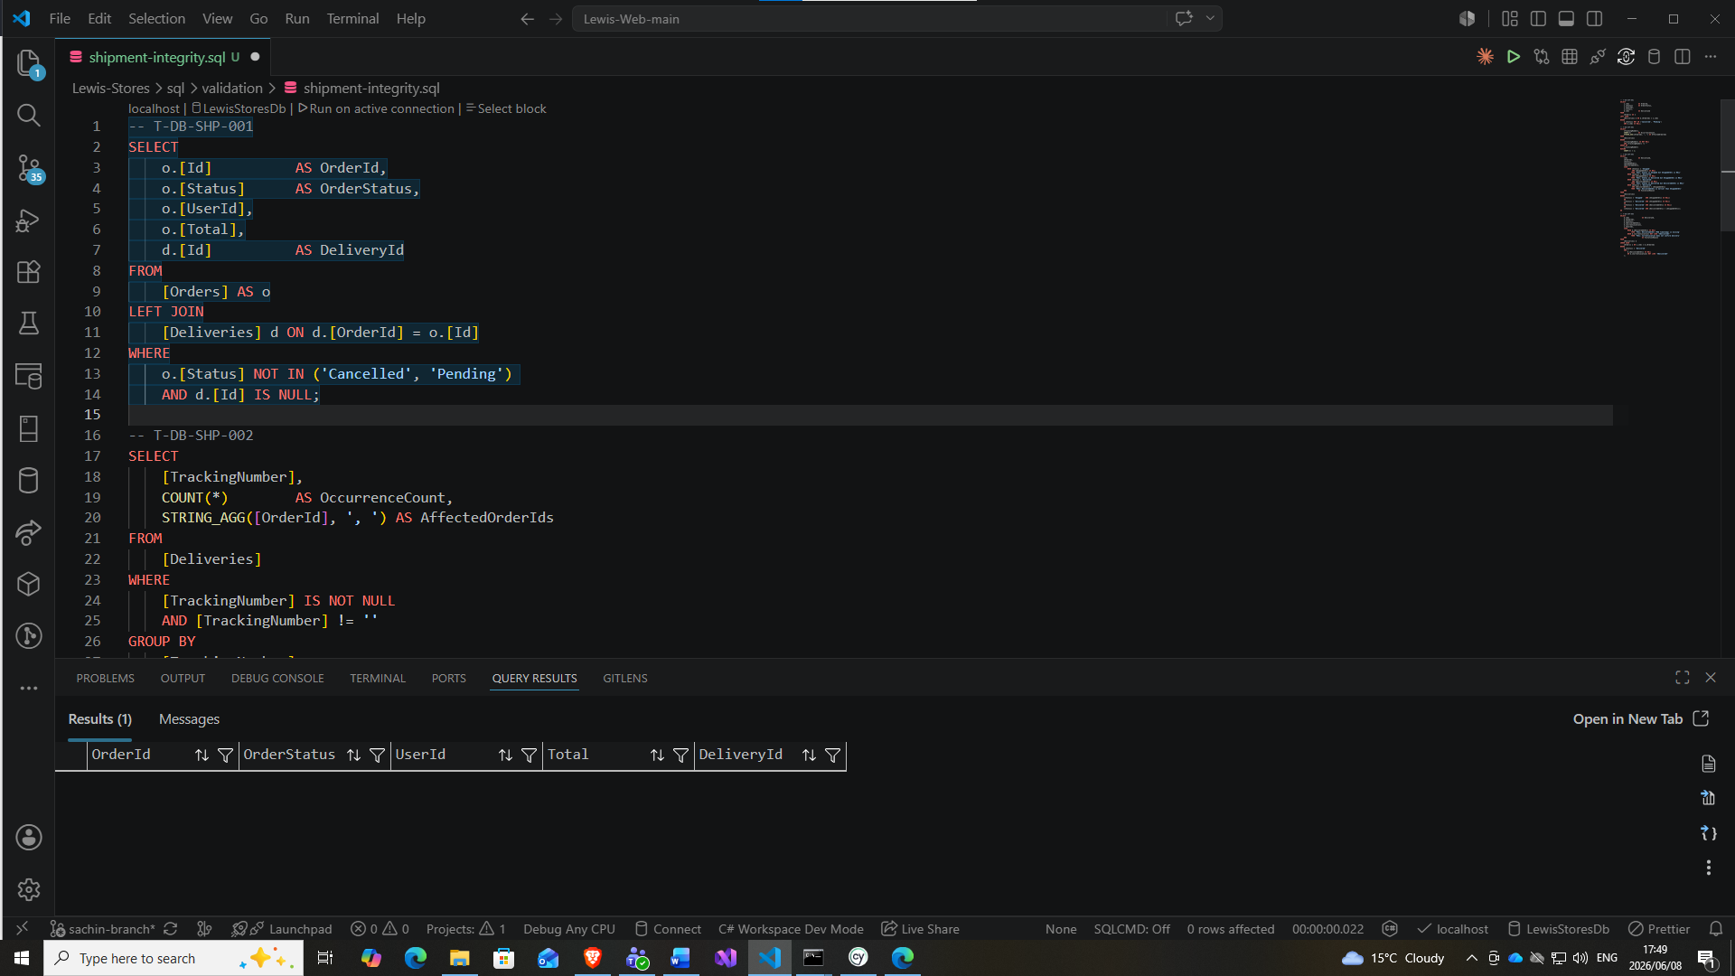

- Tracking numbers are unique per shipment
-- ============================================================ -- T-DB-SHP-002 -- Tracking numbers are unique per shipment -- Expectation: Zero rows returned (no duplicate tracking numbers) -- ============================================================ SELECT [TrackingNumber], COUNT(*) AS OccurrenceCount, STRING_AGG([OrderId], ', ') AS AffectedOrderIds FROM [Deliveries] WHERE [TrackingNumber] IS NOT NULL AND [TrackingNumber] != '' GROUP BY [TrackingNumber] HAVING COUNT(*) > 1; GO -- PASS if 0 rows returned -- FAIL if any rows returned (duplicate tracking number detected)
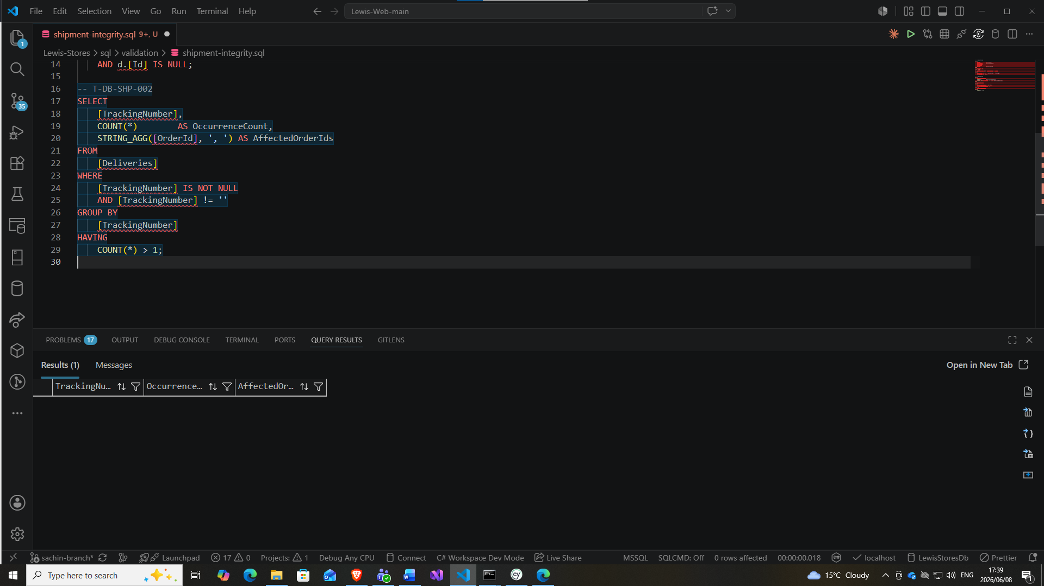

- Shipment status progression is valid (no skipped states)
-- ============================================================ -- T-DB-SHP-003 -- Shipment status progression is valid (no illegal state transitions) -- Valid progression: Processing → Shipped → Delivered -- Any state → Cancelled (always allowed) -- A "Shipped" or "Delivered" record MUST have ShippedAtUtc set. -- A "Delivered" record MUST have DeliveredAtUtc set. -- Expectation: Zero rows returned -- ============================================================ SELECT [Id] AS DeliveryId, [OrderId], [Status], [ShippedAtUtc], [DeliveredAtUtc], CASE WHEN [Status] = 'Shipped' AND [ShippedAtUtc] IS NULL THEN 'FAIL: Status is Shipped but ShippedAtUtc is NULL' WHEN [Status] = 'Delivered' AND [ShippedAtUtc] IS NULL THEN 'FAIL: Status is Delivered but ShippedAtUtc is NULL' WHEN [Status] = 'Delivered' AND [DeliveredAtUtc] IS NULL THEN 'FAIL: Status is Delivered but DeliveredAtUtc is NULL' WHEN [Status] = 'Delivered' AND [DeliveredAtUtc] < [ShippedAtUtc] THEN 'FAIL: DeliveredAtUtc is earlier than ShippedAtUtc' END AS ViolationReason FROM [Deliveries] WHERE -- Shipped without a shipped timestamp ([Status] = 'Shipped' AND [ShippedAtUtc] IS NULL) OR -- Delivered without a shipped timestamp ([Status] = 'Delivered' AND [ShippedAtUtc] IS NULL) OR -- Delivered without a delivery timestamp (missing POD — overlaps T-DB-SHP-004) ([Status] = 'Delivered' AND [DeliveredAtUtc] IS NULL) OR -- Delivery timestamp precedes ship timestamp (impossible sequence) ([Status] = 'Delivered' AND [DeliveredAtUtc] < [ShippedAtUtc]); GO -- PASS if 0 rows returned -- FAIL if any rows returned — ViolationReason explains the specific breach
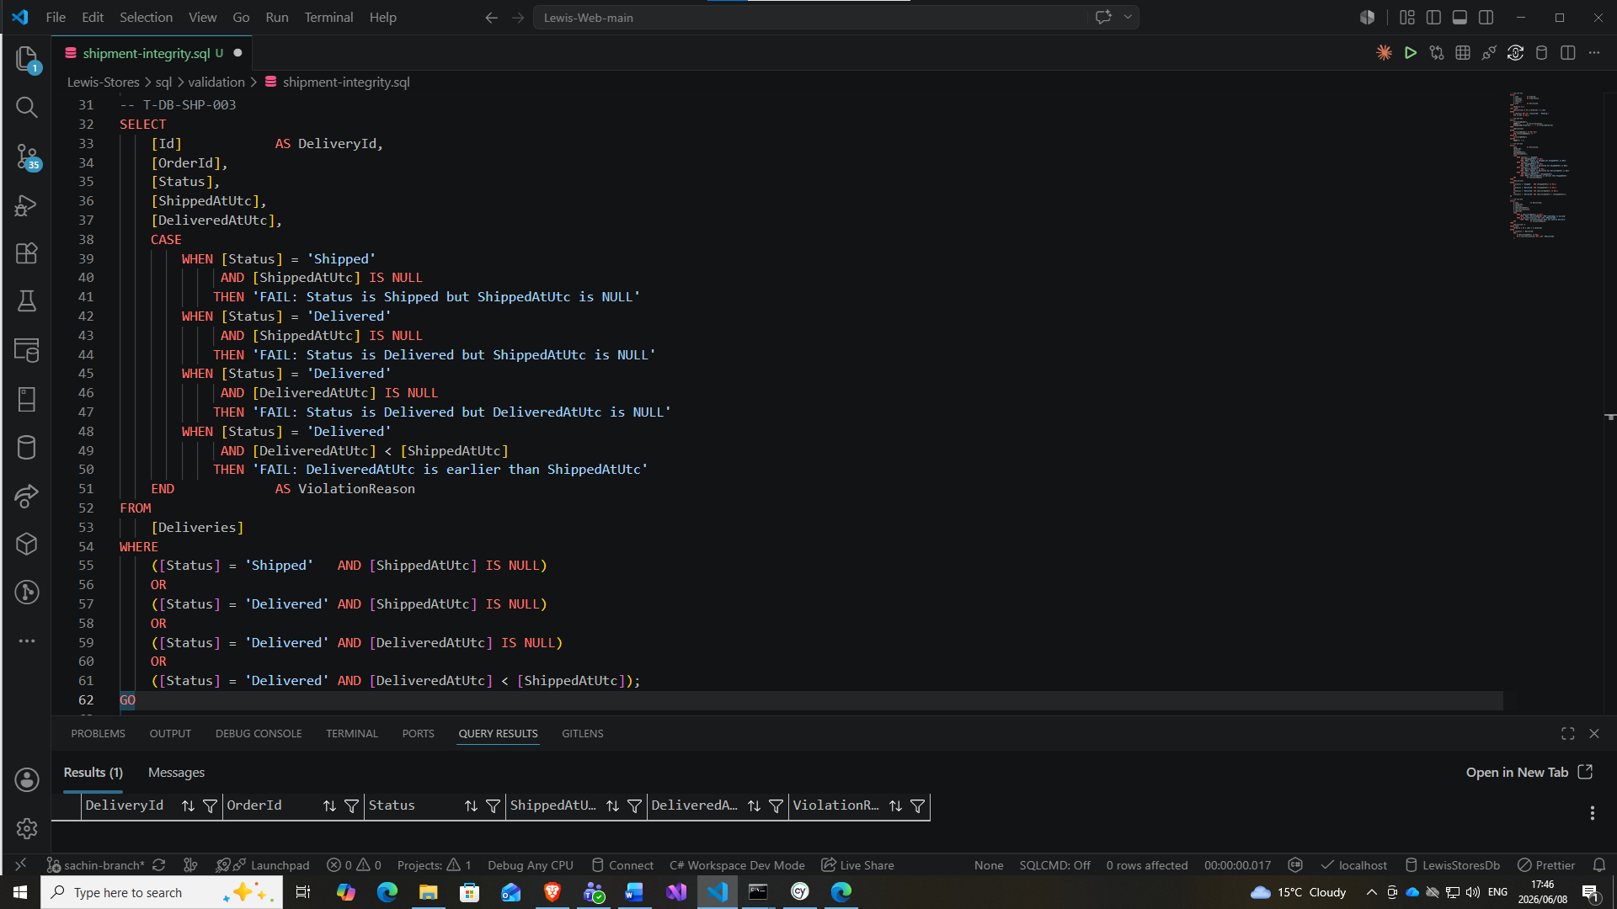

- Proof of delivery (POD) recorded for all delivered orders
-- ============================================================ -- T-DB-SHP-004 -- Proof of Delivery (POD) is recorded for all delivered orders -- Checks: DeliveredAtUtc is populated AND CurrentLocation confirms delivery -- Expectation: Zero rows returned -- ============================================================ SELECT d.[Id] AS DeliveryId, d.[OrderId], d.[Status], d.[DeliveredAtUtc], d.[CurrentLocation], o.[UserId], CASE WHEN d.[DeliveredAtUtc] IS NULL THEN 'FAIL: DeliveredAtUtc (POD timestamp) is missing' WHEN d.[CurrentLocation] NOT LIKE '%Delivered%' THEN 'FAIL: CurrentLocation does not confirm delivery' END AS ViolationReason FROM [Deliveries] d INNER JOIN [Orders] o ON o.[Id] = d.[OrderId] WHERE d.[Status] = 'Delivered' AND ( d.[DeliveredAtUtc] IS NULL OR d.[CurrentLocation] NOT LIKE '%Delivered%' ); GO -- PASS if 0 rows returned -- FAIL if any rows returned — POD evidence is incomplete

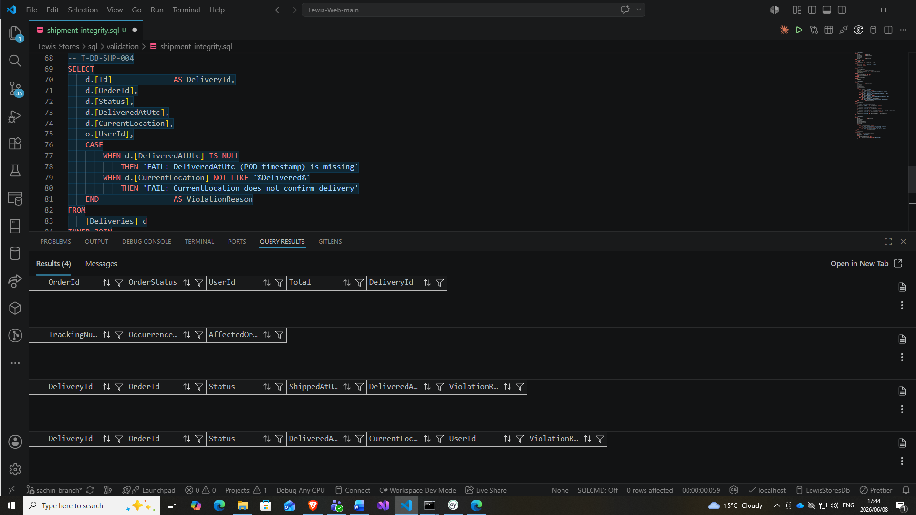
FR-005: Returns & Refunds Process

Postman: Returns, error handling API tests
Implementing 4 returns and 4 global error handling tests.
validate 30-day window, refund amount, inventory restored
- Initiate return
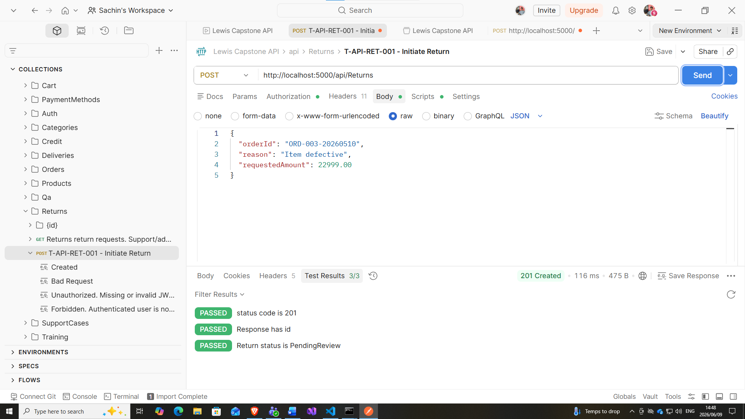

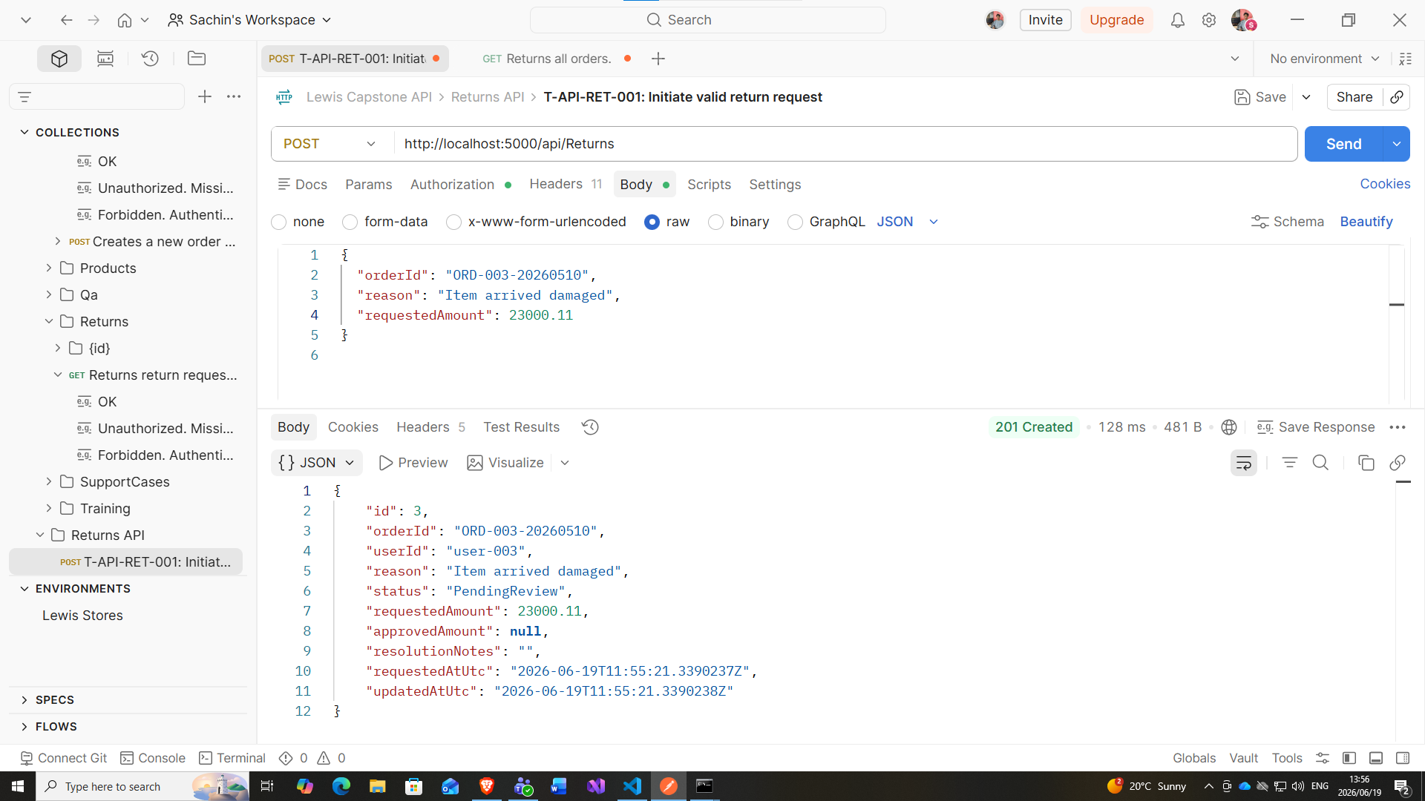

- T-API-RET-002: Get return status for an existing return (get validity from sql)
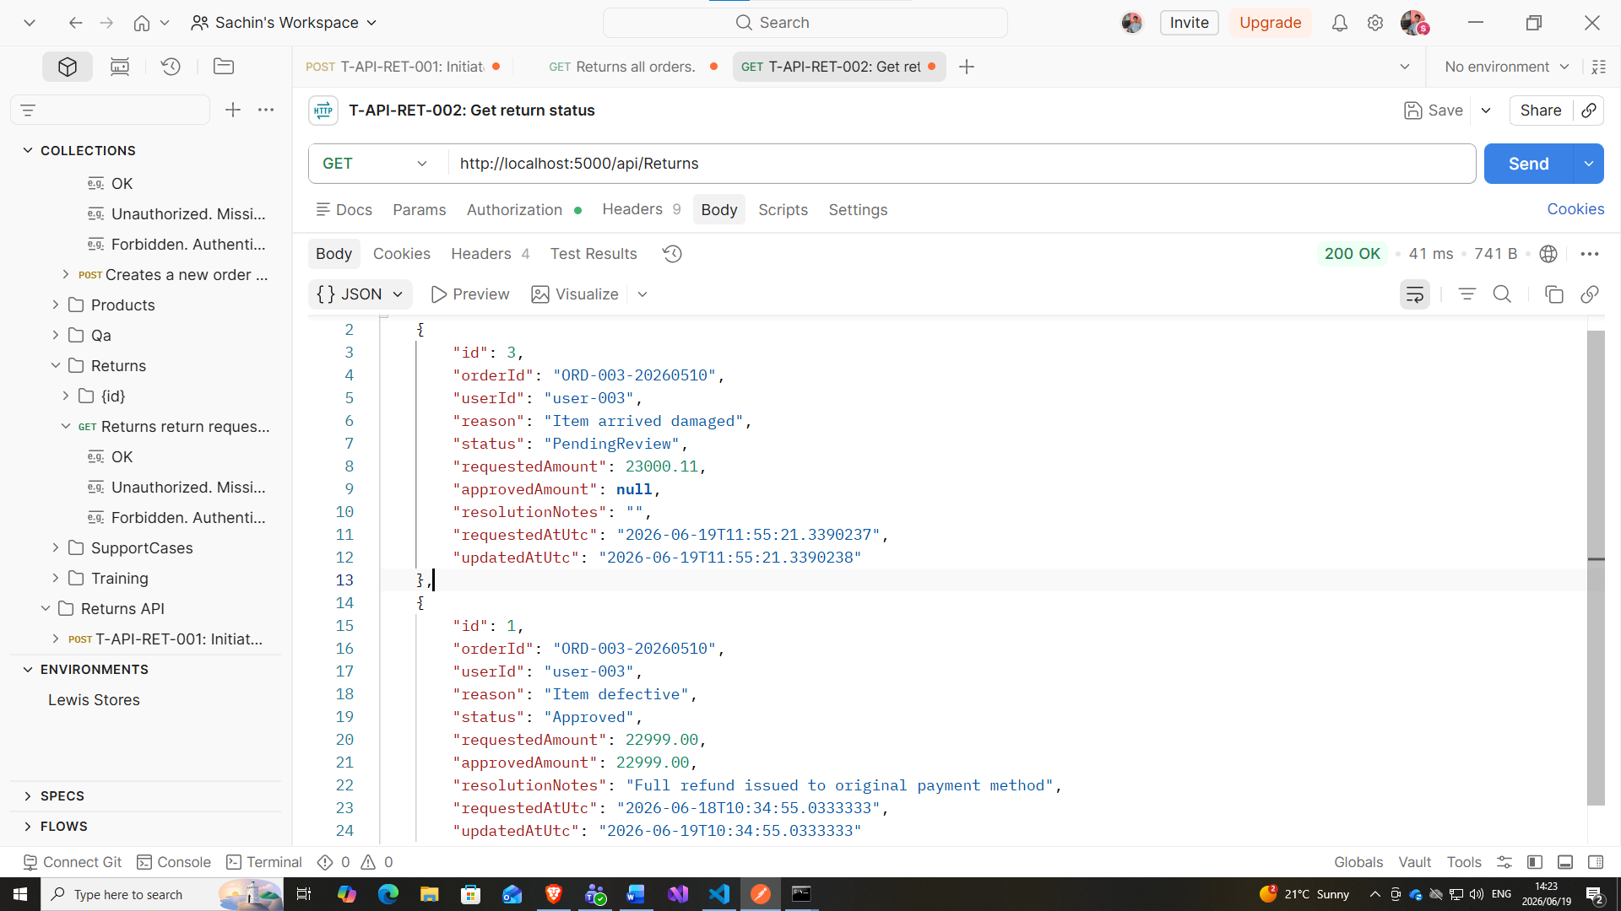

- T-API-RET-003: Refund processed for approved return
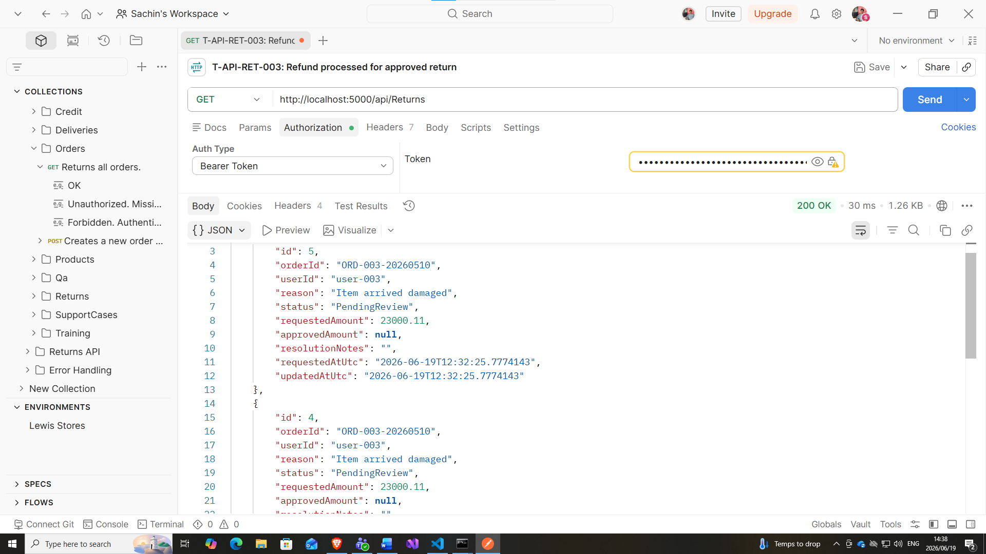

- T-API-RET-004: Return outside 30-day window rejected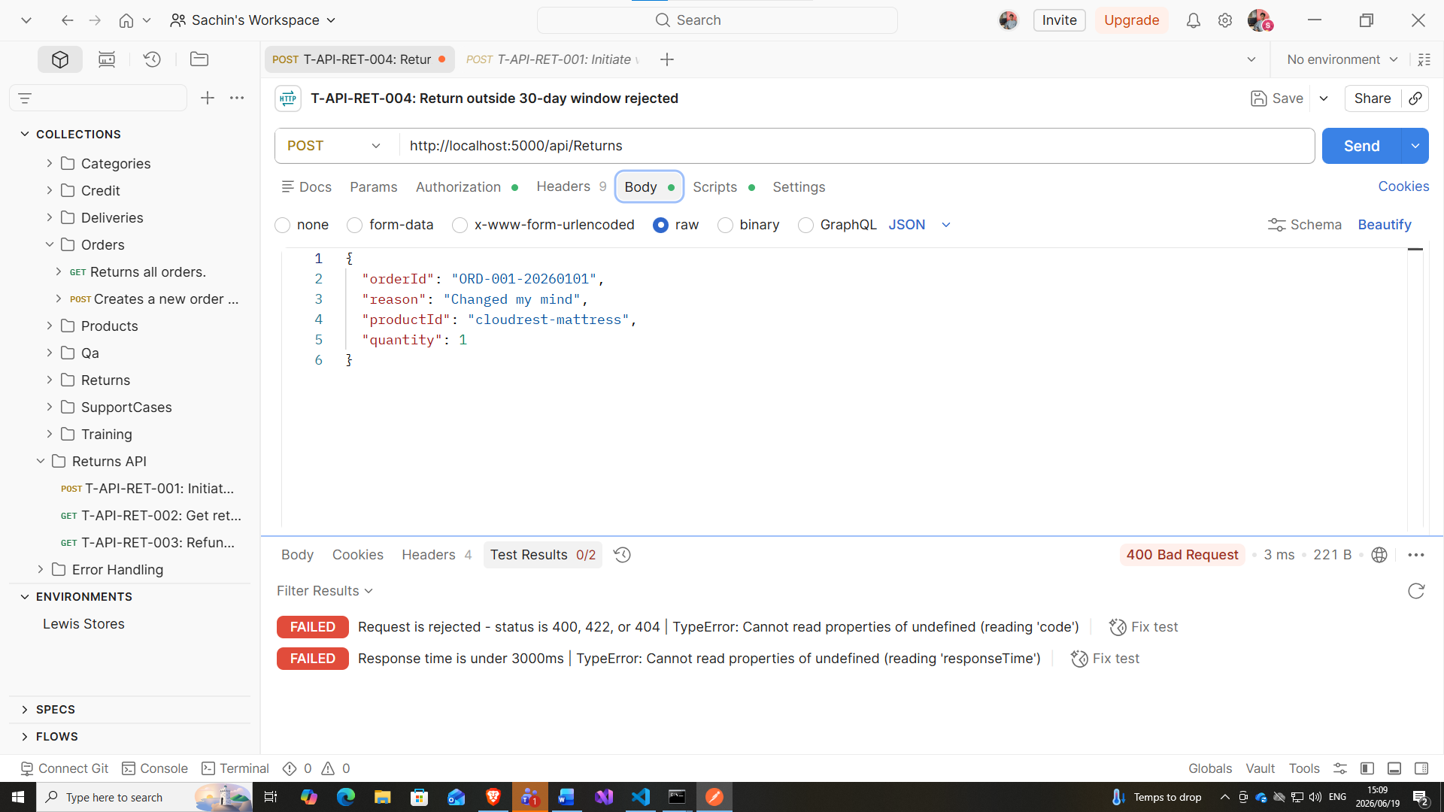

FR-005: Returns & Refunds Process

Postman Error handling
- T-API-ERR-001: Invalid request body returns 400
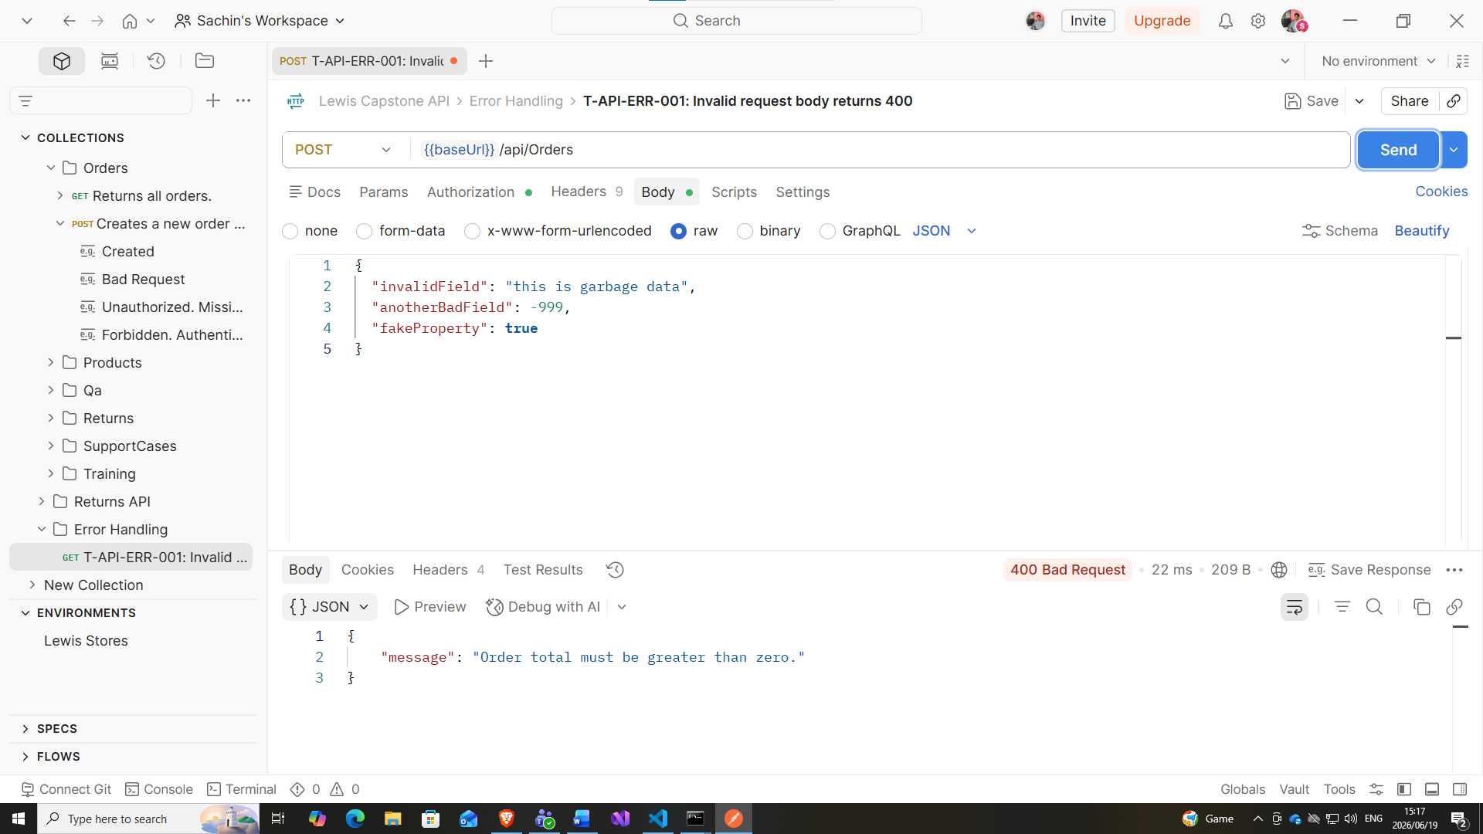

- T-API-ERR-002: Unauthenticated request returns 401
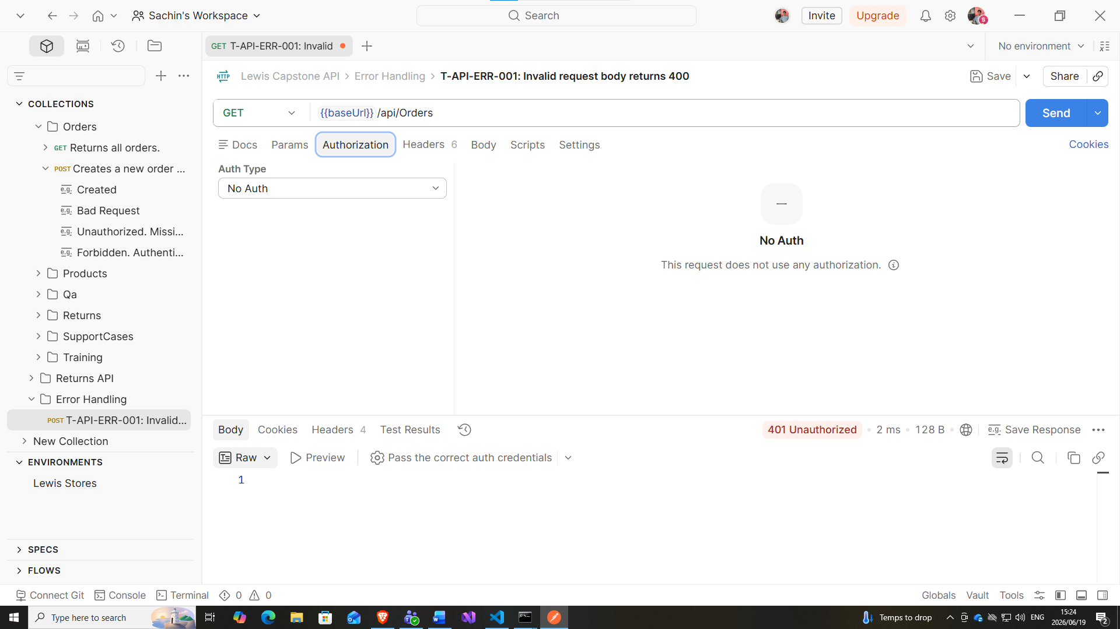

Here we are on to the order management portion which we did in cypress. We ran tests such as products loading successfully on storefront, adding and removing products from cart, invalid coupon codes and idempotency. we had a collection of 10 test case for order management, of which, 7 passed and 3 failed. On the Orders portal on the UI the view button was broken, meaning that a customer cannot edit or view their order details.

Another module we tested in cypress was, payment and delivery tracking. Where we tested valid card payment succeeds, invalid card number or details fails, declined card handled gracefully and a tracking is assigned after payment is confirmed.

SQL – shipment data integrity, every paid order has a shipment record, tracking numbers are unique per shipment, progression status is valid (system states whether the product is being processed, order confirmed, shipped, delivered etc.) all these validation tests passed

API – returns in postman, initiating a return, getting returned status, refund successful on approved return, and also checking if a customer can return a product after 30 days, which failed meaning that a customer attempting to initiate a return on day 31 would be processed.

Some of the bugs we found,
Product images are incorrect or missing on storefront, which I wont classify was too servere, even though it would dampen the user experience a bit.
A few that are a bit more severe are that the view button on the order history page does not work meaning that a customer cannot view or edit their orders
And idempotency failure, which is if a customer double clicks on a the checkout button, it would create 2 orders, whereas it should’ve only recorded the first one and assign a unique code or reference ID so there are no duplicates

